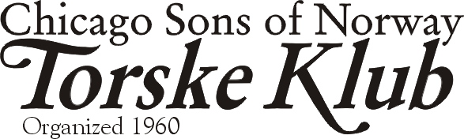
A Wee Bit o’Irish Meeting
March 13, 2004

Dear Torske Klub Member and friends of the Torske Klub,

Our March Torske Klub meeting will be held on March 13, 2004 at the Des Plaines Elks Club, 495 Lee Street, Des Plaines, IL (847-824-1556). Cocktail hour begins at Noon; Dinner starts promptly at 1:00 P.M. when, according to our tradition, our BOSS, Robert Alsaker, rings the bell.

We have as our speaker our own member, Ken Nordan. We highlighted Ken in the January letter noting his graduation from Dominican University with a Masters in Knowledge Management. In this high-tech world, Knowledge Management is an emerging discipline that combines the studies of Library Science, Computer Science and Business Administration. He’ll talk about that and his Norwegian background. Our Torskemaster for the day is our talented and well-spoken member, Bill Schreidrich.

Make Your March Dinner Reservation before TUESDAY NOON, March 9, 2004…
…to insure that you receive a fresh fish dinner. I put out an email request for reservations the day before the due date last month since we had only 27 reservations. We had an excellent response with over 60 attending the dinner; an excellent attendance for a February. Thanks for the prompt reservations.

Call 630-443-6839 at any time day or night to leave a reservation. As usual, please leave your MEMBERSHIP NUMBER, NAME, and the TOTAL number of people in your party. The same information is required when you reserve for other members. As we did last year, this reservation phone is usually unattended since it is an answering system only. It will ring 4 times before answering. If you need to speak to me urgently, please call my office at 847-781-6820 during weekday business hours. If I am not there, leave a message at either of the phones and I’ll get back to you.

For those with email, feel free to send me a note to secretary@torskeklub.org with the same information and the message title “Torske Klub Reservation”. I will reply to that with a confirmation of receipt. I believe that I have an internet email account for everyone that wants an email notice. If you wish to be included or excluded from this list, please contact me.

We have March dinner reservations from 3, 13C, 22, 43A, 44, 47, 51, 55, 64A, 69A, 73C, 78, 85, 98, 126, 143, 171.

No New Members This Month?!
…because I screwed up and didn’t have enough membership applications at the last dinner. The penitence for that is an attachment to this letter for your guests and for any men interested in membership. This is NOT for existing members, just a form for new members. Make a copy, if you wish or call me if you need more. Some of you on the mailing list have received a letter because a friend suggested that you’ll be interested in the klub. The dues pay for the letter among other costs, so it will stop coming in the future if you don’t contribute. If you have someone who may be interested, give the klub your address. We’ll mail a few letters to them.
February Torske Klub Meeting
Our speaker for the February Dinner was James Peiper, a representative of the Federal Reserve System. We had an excellent dinner for “sweater day”. We also thank Ralph Haug for his duties as Torskemaster and for his complete repertoire of jokes. We look forward to hearing them again next year Ralph! ☺
News from the Boss
We had a great sweater day and thanks to Ray and Wolfgang for the photos. We believe that we have a photo of everyone that attended that event, so the Torske Klub will print those photos and have them at the next meeting for each of you. Thanks again for a great turnout.

News from the Program Chairman
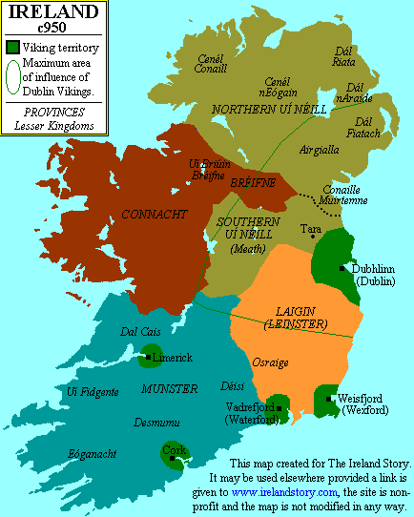
The Vikings in Ireland c. 950 A.D.
Ray Newgard announced at the last meeting some excellent future programs for this year:
- April 2004 – Father/son/daughter day – Chicago Fire Soccer Player
- May 2004 – Ladies Day/Klub Anniversary – Normennenes Singers
- September 2004 – Pre-election Political Candidate, Ray notes that the president may coincidentally be in town
- October 2004 – Paul Anderson, our Norwegian Consul General, speaking on Leif Ericcson day
- November 2004 – Steve Baskerville – WBBM Weatherman

Ireland, that fine Scandinavian Colony
As we celebrate St. Patrick’s Day in Chicago, the Scandinavian community should take a special pride in the founding of a number of Irish cities as the Vikings “colonized” the island. They founded the settlements of Weisfjord (Wexford), Vadrefjord (Waterford), and Dubhlinn (Dublin), among others. So put a little Irish whiskey in your aquavit as we toast our distant cousins this month.

We also pass a special greeting and regards to our favorite Irish member Art Fitzgerald, who is keeping warm in Florida.

I had a couple of good Irish Jokes reserved for this spot in the letter, but some of my proofreaders are questioning the wisdom of committing these to paper, where someone’s grandmother may read them later. Therefore, you’ll have to come to the meeting to hear them.
Einar Cannelin and Ray Newgard dressed for Waukegan Medieval Festival circa 1985 (directed by Carl Johansen, son of the late boss Chris Johansen)

An Omission from last month is enclosed at the right. I wanted to add that photo from our archive of Torske Klub memorabilia with the letter from Einar.

Remember to Bring a Guest next time
- Any male guest to the Torske Klub this season, who is 21 - 50 years old, will have his first dinner paid for by the Klub if he joins the Torske Klub.

Beste Hilsen and erin go bragh,
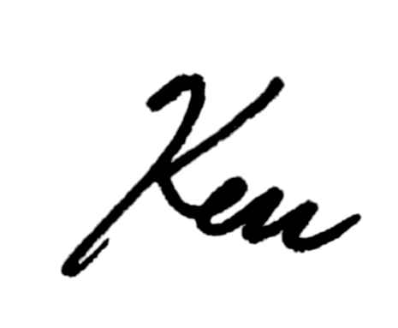
Ken O’Larson

